**Power BI Installation**

**1. After installation**

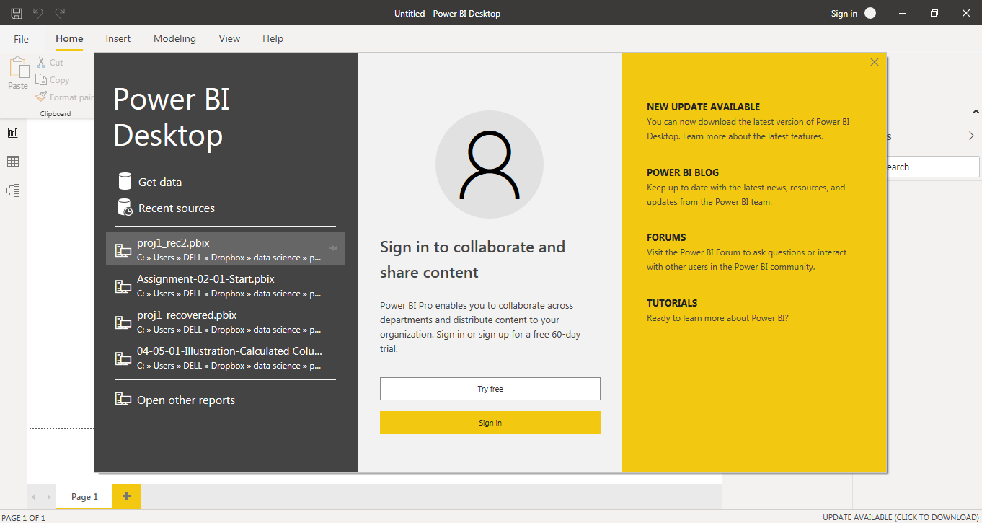

**Report View:**

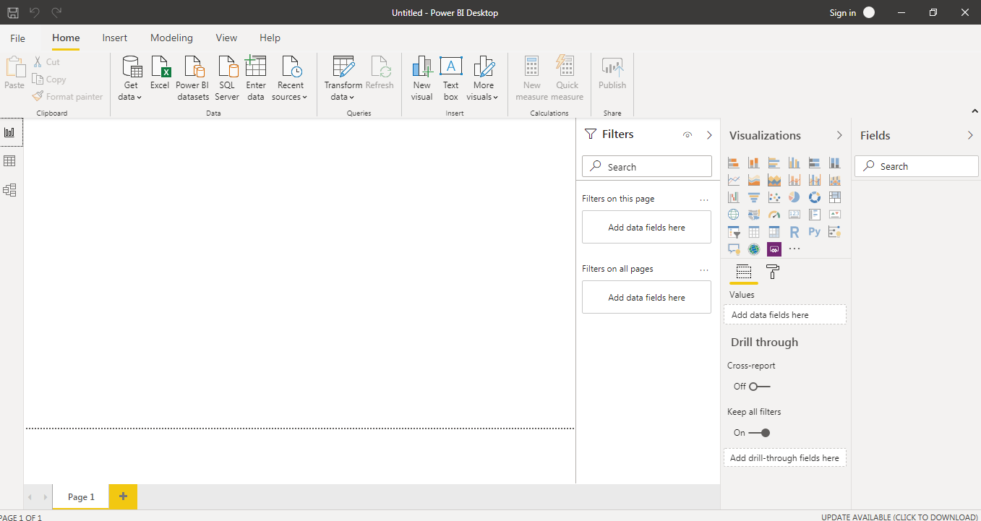

**Data View**

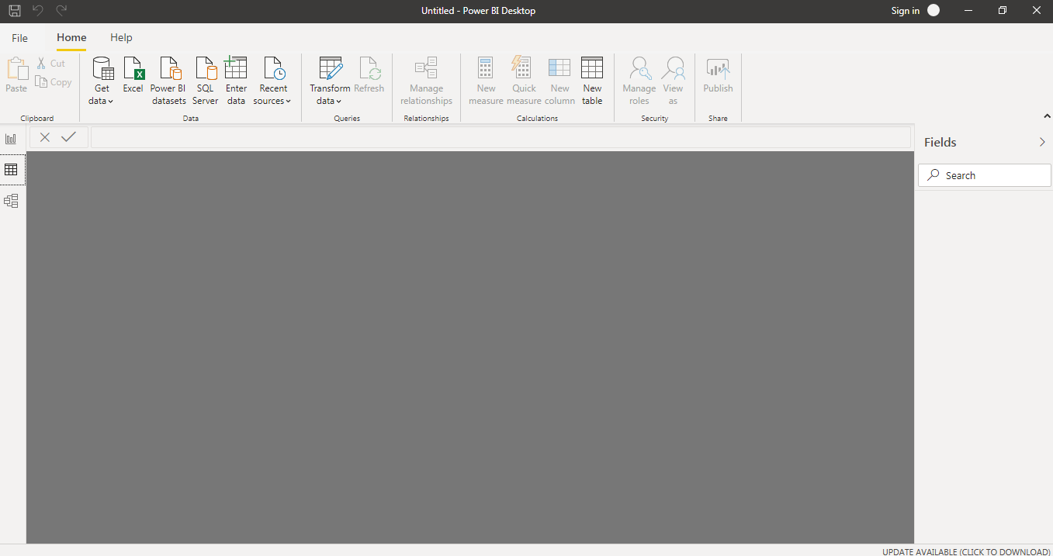

**Model View**

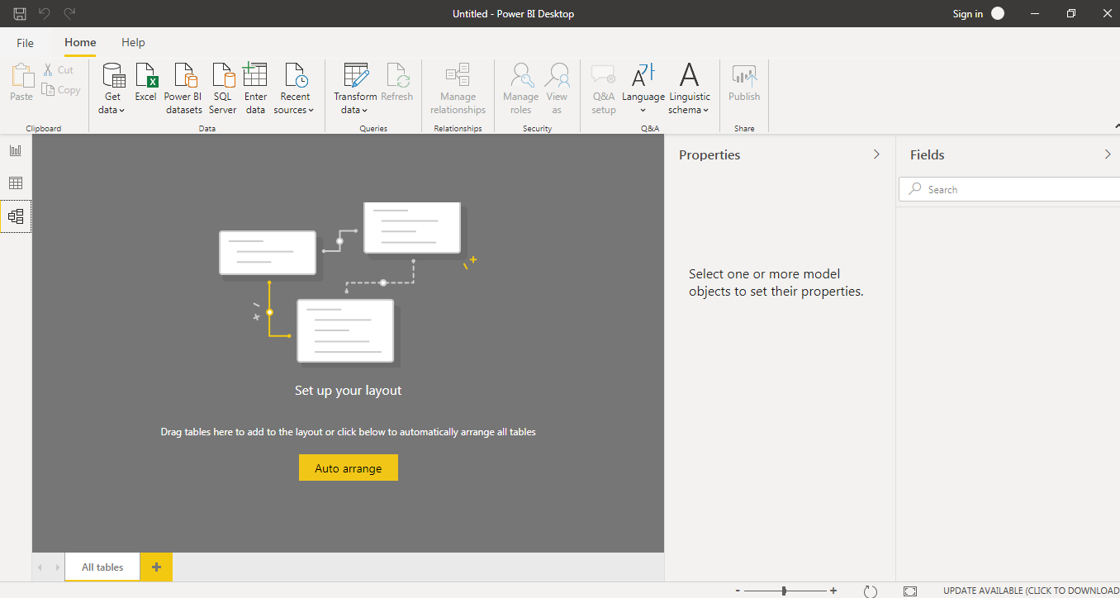

**Power Query Editor**

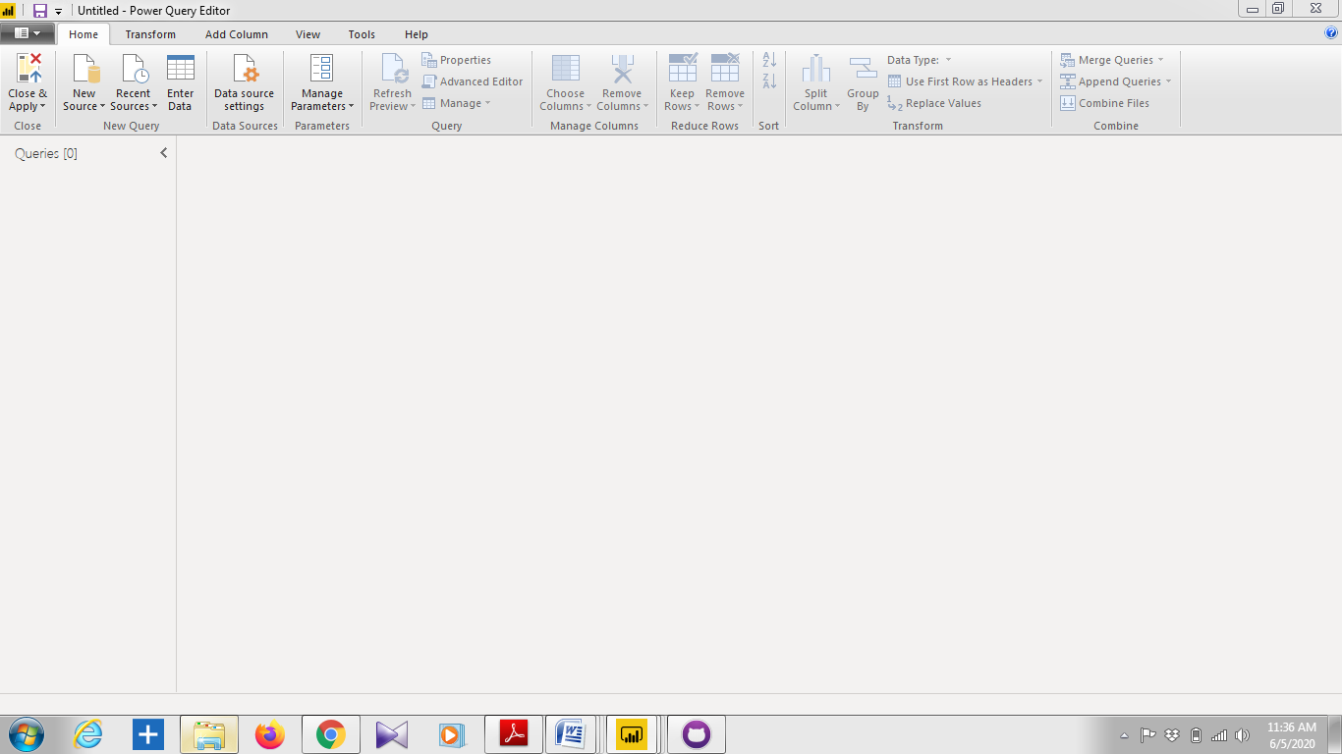

**Advance Editor**

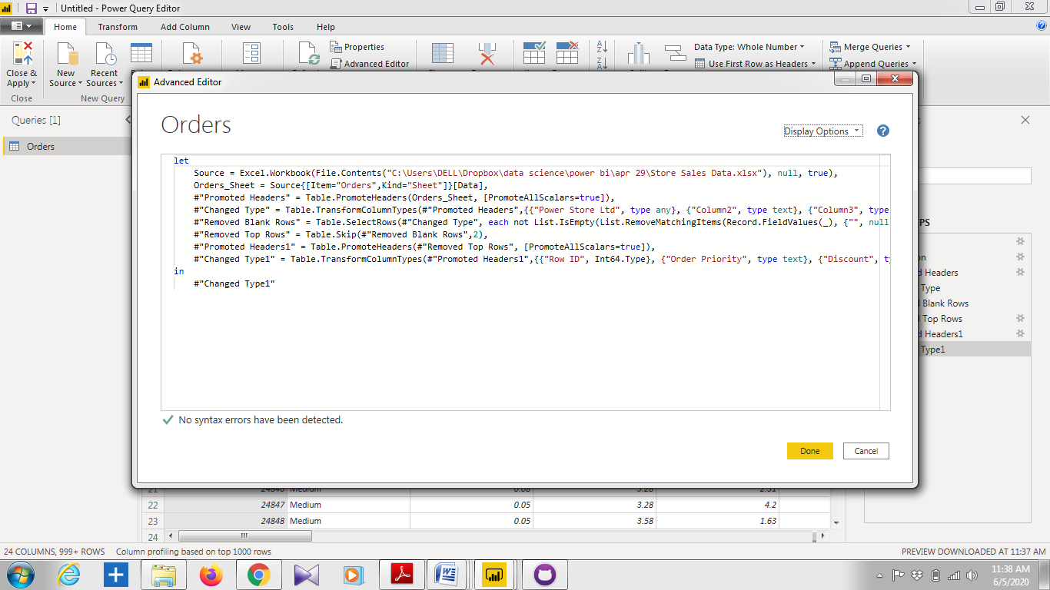

**Power BI Desktop**

* Create rich, interactive reports with visual analytics

### Connect to your data, wherever it is

### Prep and model your data with ease

### Provide advanced analytics with the familiarity of Office

### Deepen your data insights with AI-driven augmented analytics

### Create interactive reports customized for your business

### Author for everyone, anywhere

**Price** : Free

**Power BI Pro**

* Self-service and modern BI in the cloud
* Collaboration, publishing, sharing, and ad-hoc analysis
* Fully managed by Microsoft

**Price** : US $ 9.99 monthly per user

**Power BI Premium**

* Enterprise BI, big data analytics, cloud and on-premises reporting
* Advanced administration and deployment controls
* Dedicated cloud compute and storage resources
* Allows any user to consume Power BI content

**Price** : US $ 4,995 monthly per dedicated cloud compute and storage resource with annual subscription